ML Algorithms

XG Boost for Regression:
The algorithms just work like Gradient boosting but with some changes in forming a tree as it’s a tree algorithm and works on non-linear data also
It effectively creates a "Step Function" that approximates a curve, rather than drawing a single straight line.
The algo:
Let's say we want to predict House Price.
- Goal: Minimize the error (Residual).
- Objective Function: Training Loss (MSE) + Regularization.
As you can see gradient boosting can have any loss function and is regularized also
Step 1: Initial Prediction
- XG Boost starts with a base prediction, usually 0.5 (or the average price).
Step 2: Calculate Gradient and Hessian This is the "Extreme" part. Standard Gradient Boosting only uses the Gradient (Slope). XG Boost uses Calculus (Taylor Series Expansion).
- Gradient (g): The First Derivative. (Direction of the error). "The price needs to go UP."
- Hessian (h): The Second Derivative. (Curvature of the error). "The price needs to go up, but slowly because we are getting close."
Step 3: Build the Tree (The Score Formula) XG Boost doesn't just guess where to split. It uses a math formula to find the best split:
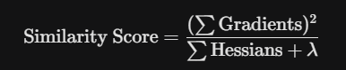
- It calculates this score for every possible split point (e.g., "Size < 1000", "Size < 1001").
- It picks the split that maximizes the Gain (Similarity of Children - Similarity of Parent).
- lambda (Lambda): This is the Regularization term. If the Hessian (confidence) is low, Lambda dominates the denominator, shrinking the score. This prevents the model from trusting weak data.
Step 4: Pruning It grows the tree deep, then looks at the Gain of the bottom branches. If Gain < Gamma (another penalty parameter), it chops the branch off.

Example:
The Scenario
- Goal: Predict Dosage (y) based on Age (x).
- Parameters:
  - Initial Prediction: 0.5
  - Learning Rate: 0.3
  - Regularization (lambda): 0 (for simplicity)
  - Loss Function: MSE (Mean Squared Error)

- Step 1: Initial State & Derivatives
We start by calculating how wrong the initial guess is.

Person | Age (x) | Actual Dosage (y) | Initial Pred (p0​) | Residual (y−p0​) | Gradient g=−(y−p) | Hessian h=1
A | 10 | 10 | 0.5 | 9.5 | -9.5 | 1
B | 20 | 25 | 0.5 | 24.5 | -24.5 | 1
C | 40 | 28 | 0.5 | 27.5 | -27.5 | 1

Gradient (g): The "Direction" we need to move. (Negative sign means "Prediction is too low").
Hessian (h): The "Weight" of the error. For Linear Regression (MSE), this is always 1.

Step 2: Calculating Similarity Scores (Finding the Split)
We need to group the errors. We try different split points and calculate the Similarity Score for each group.
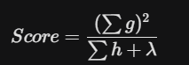
Split Strategy | Group | Persons | Sum of g (∑g) | Sum of h (∑h) | Similarity Score | Total Gain
Root (No Split) | All | A, B, C | -61.5 | 3 | 1260.75 | N/A
Split 1: Age < 15 | Left | A | -9.5 | 1 | 90.25
 | Right | B, C | -52.0 | 2 | 1352.0
 |  |  |  |  | Total: $1442.25$ | +181.5
Split 2: Age < 30 | Left | A, B | -34.0 | 2 | 578.0
 | Right | C | -27.5 | 1 | 756.25
 |  |  |  |  | Total: $1334.25$ | +73.5

Conclusion:
- Split 1 Gain: 181.5
- Split 2 Gain: 73.5
- Winner: Split 1 (Age < 15) because it gives the highest Gain.

Calculating Leaf Weights (Output Values)
Now that we have the groups (Leaves), we calculate what number each leaf should output.
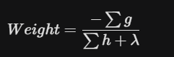
Leaf Node | Persons | Sum of g | Sum of h | Leaf Output Formula | Final Output Value
Left Leaf | A | -9.5 | 1 | -(-9.5) / 1 | +9.5
Right Leaf | B, C | -52.0 | 2 | -(-52.0) / 2 | +26.0

Step 4: Updating Predictions
We combine the initial guess with the new leaf output, scaled by the Learning Rate ($\eta = 0.3$).
New-Pred = Old-Pred + (learning rate * Leaf-Output)

Person | Age | Actual (y) | Old Pred (p0​) | Leaf Output | Update Math | New Pred (p1​) | Did it improve?
A | 10 | 10 | 0.5 | +9.5 | 0.5+(0.3*9.5) | 3.35 | Yes (0.5 -> 3.35)
B | 20 | 25 | 0.5 | +26.0 | 0.5+(0.3*26.0) | 8.30 | Yes (0.5 -> 8.3)
C | 40 | 28 | 0.5 | +26.0 | 0.5+(0.3*26.0) | 8.30 | Yes (0.5 -> 8.3)

XG boost for Classification:
Its identical to regression but cannot calculate residual directly
Instead, we work with Log-Odds and use a different Loss Function.
Will see the algo with example:
Let's predict if a user Likes a Movie (1) or Not (0) based on Age.
Data:
- Person A (Age 10): Likes it (1).
- Person B (Age 20): Hates it (0).
- Person C (Age 40): Hates it (0).
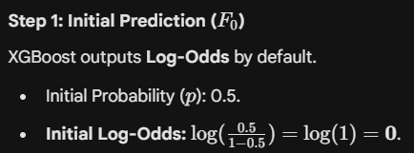

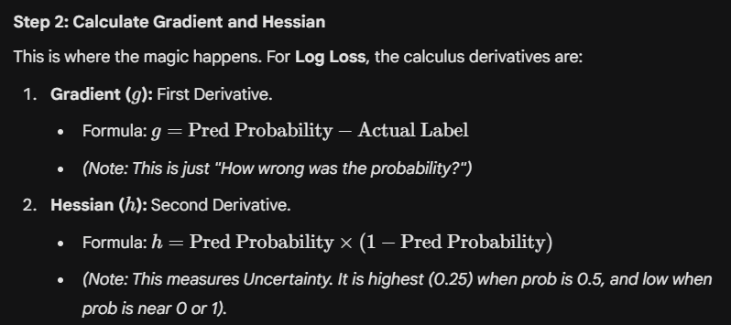

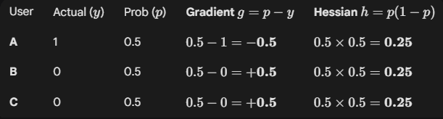

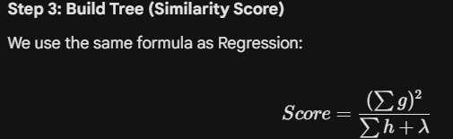

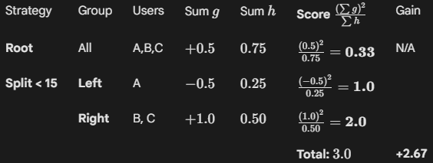
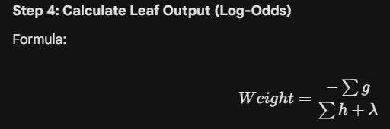

• Left Leaf (+2.0): Increases Log-Odds (Means "More likely to be 1").
• Right Leaf (-2.0): Decreases Log-Odds (Means "More likely to be 0").
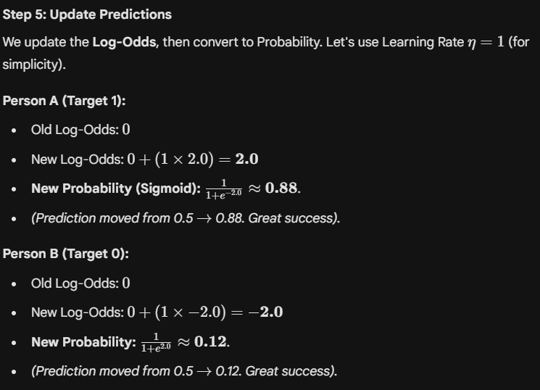

Finaly we need this:
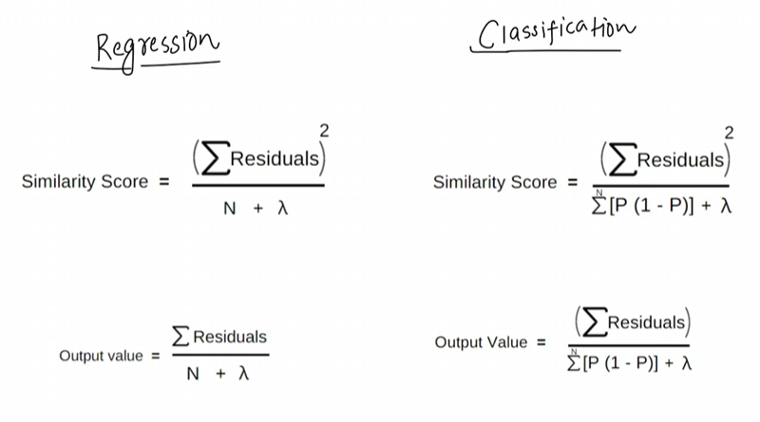

Gradients == Residual

Gradient Boosting Loss function:
It is combination of loss function and regularization term
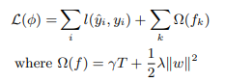
The second term Ω penalizes the complexity of the model (i.e., the regression tree functions)

Formally, let ˆy (t) i be the prediction of the i-th instance at the t-th iteration, we will need to add ft to minimize the following objective.
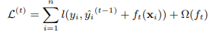

So, we can do gradient descent on this as it forms steps which don’t have slopes and can’t find partial differentiation
Therefore, we use Taylor series to make it differentiable
Formula:
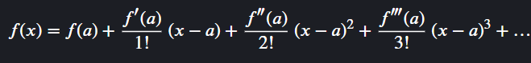
This is how will apply it,
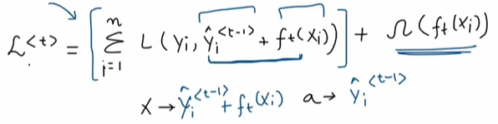
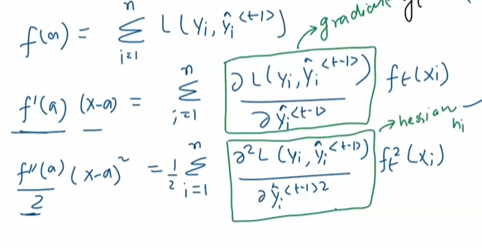
The two green boxes represent gradient and hessian, g_{i} and h_{i}
formula comes out to be, now we have made equation polynomial and simple
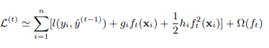
We can remove the constant terms to obtain the following simplified objective at step t.
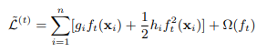

This equation can be simplified to this
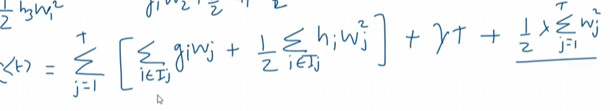
Explain:
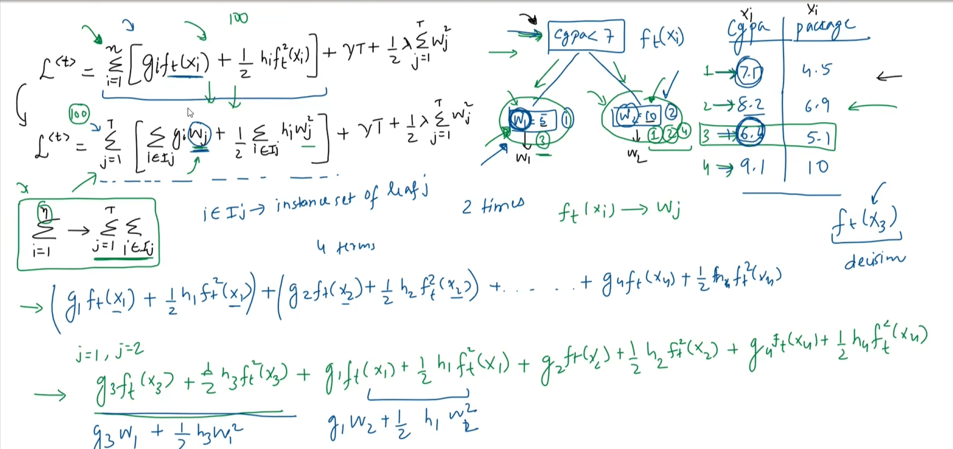
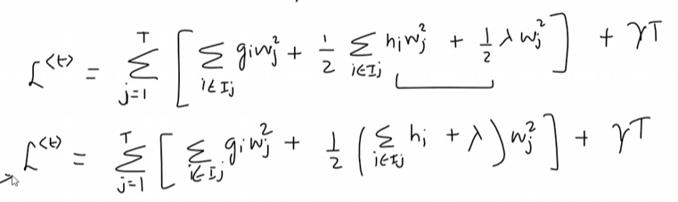
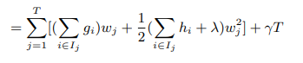
Differentiation of this
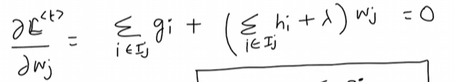
We get w_{j}:
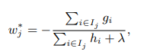

Finding gradient and hessian for regression first
We got this at first,
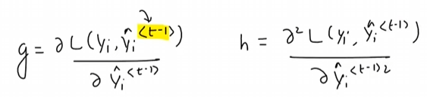

In regression, the g comes out to be sum of residual
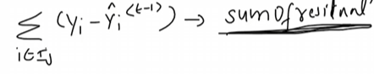
And g comes out to be no of residual in the leaf
And the formula comes out to be,
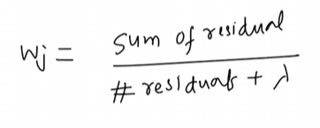

In classification, it comes out be as
As loss is Log loss of gradient boosting

And w_{j} comes out to be
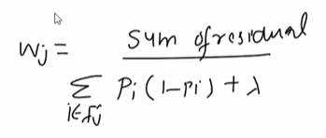
P_{i} is predicted probability of previous iteration
Now for similarity score, (proof)
We get loss function as
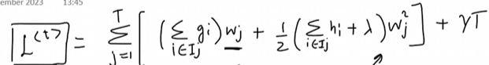
If we put value of w_{j} in it we can find the minimum loss for the parameter after using w_{j}
After full simplification it comes out to be
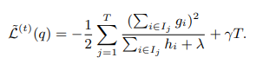

Then the loss reduction after the split is
Normally it is impossible to enumerate all the possible tree structures q. A greedy algorithm that starts from a single leaf and iteratively adds branches to the tree is used instead. Assume that IL and IR are the instance sets of left and right nodes after the split. Letting I = IL ∪ IR, then the loss reduction after the split is given by
